Patrick Warren

CIS 310-01

Assignment 6 – A6

Due 10/11/2017

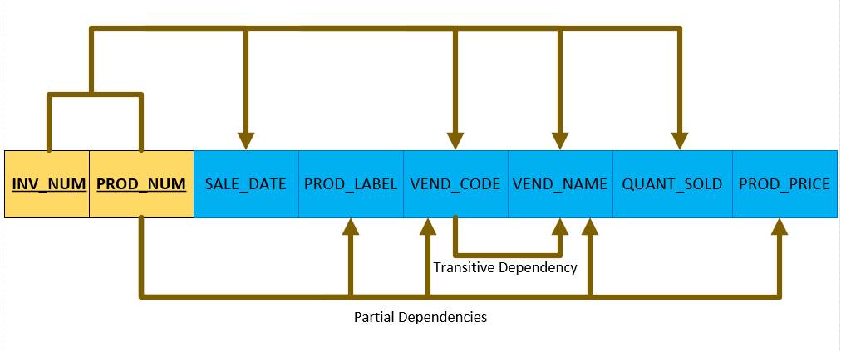

1. The table on page 238 is in 1st Normal Form because all rows are unique.
2. The diagram above is NOT in 2nd Normal Form, because there is a transitive dependency between VEND_CODE and VEND_NAME (non-key attribute identifying another non-key attribute.)

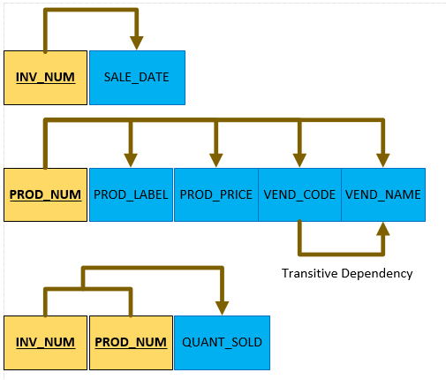

1. The diagrams above are not in 3rd Normal Form because there is still a transitive dependency involved. See below for the complete normalization.

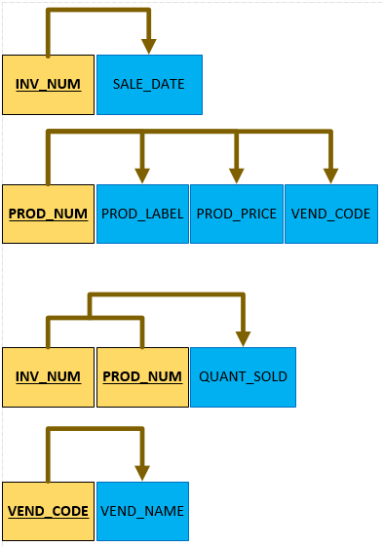

1. Crows Foot ERD of the diagram from question 4.

